**DAILY ONLINE ACTIVITIES SUMMARY**

|  |  |  |  |  |  |  |  |
| --- | --- | --- | --- | --- | --- | --- | --- |
| **Date:** | 21/06/2020 | | | | **Name:** | AMBIKA V | |
| **Sem & Sec** | 4th Sem Section'A' | | | | **USN:** | 4AL18CS005 | |
| **Online Test Summary** | | | | | | | |
| **Subject** | | _ | | | | | |
| **Max. Marks** | | _ | | **Score** | | _ | |
| **Certification Course Summary** | | | | | | | |
| **Course** | Introduction to information security | | | | | | |
| **Certificate Provider** | | | greatlearning academy | **Duration** | | | 5 hrs |
| **Coding Challenges** | | | | | | | |
| **Problem statement 1 :** Write a Java program to count number of bits to be flipped to convert A to B. | | | | | | | |
| **Status:** completed | | | | | | | |
| **Uploaded the report in Github** | | | | yes | | | |
| **If yes Repository name** | | | | https://github.com/ambika0202 | | | |
| **Uploaded the report in slack** | | | | yes | | | |

**ONLINE TEST DETAILS:N/A**

**CERTIFICATION COURSE DETAILS:**

**Name of the course**: Introduction to Information Security

**Certificate Provider**: Great Learning Academy

Today I have started a new course I.e., Introduction to Information Security .In this course you will be introduced to basic concepts of information security. You will also get to understand some of the areas and domains where information security is being used and also be exposed to new advancements in the field and areas of cutting edge research such as quantum computing, what it means to conventional information security. The course will also cover application security and software security and examines what can be done in the pre-deployment phase to secure software systems. This free course is offered as part of Great Learning's learning collaboration with the Stanford Centre for Professional Development and started to learn about **Snapshot:**

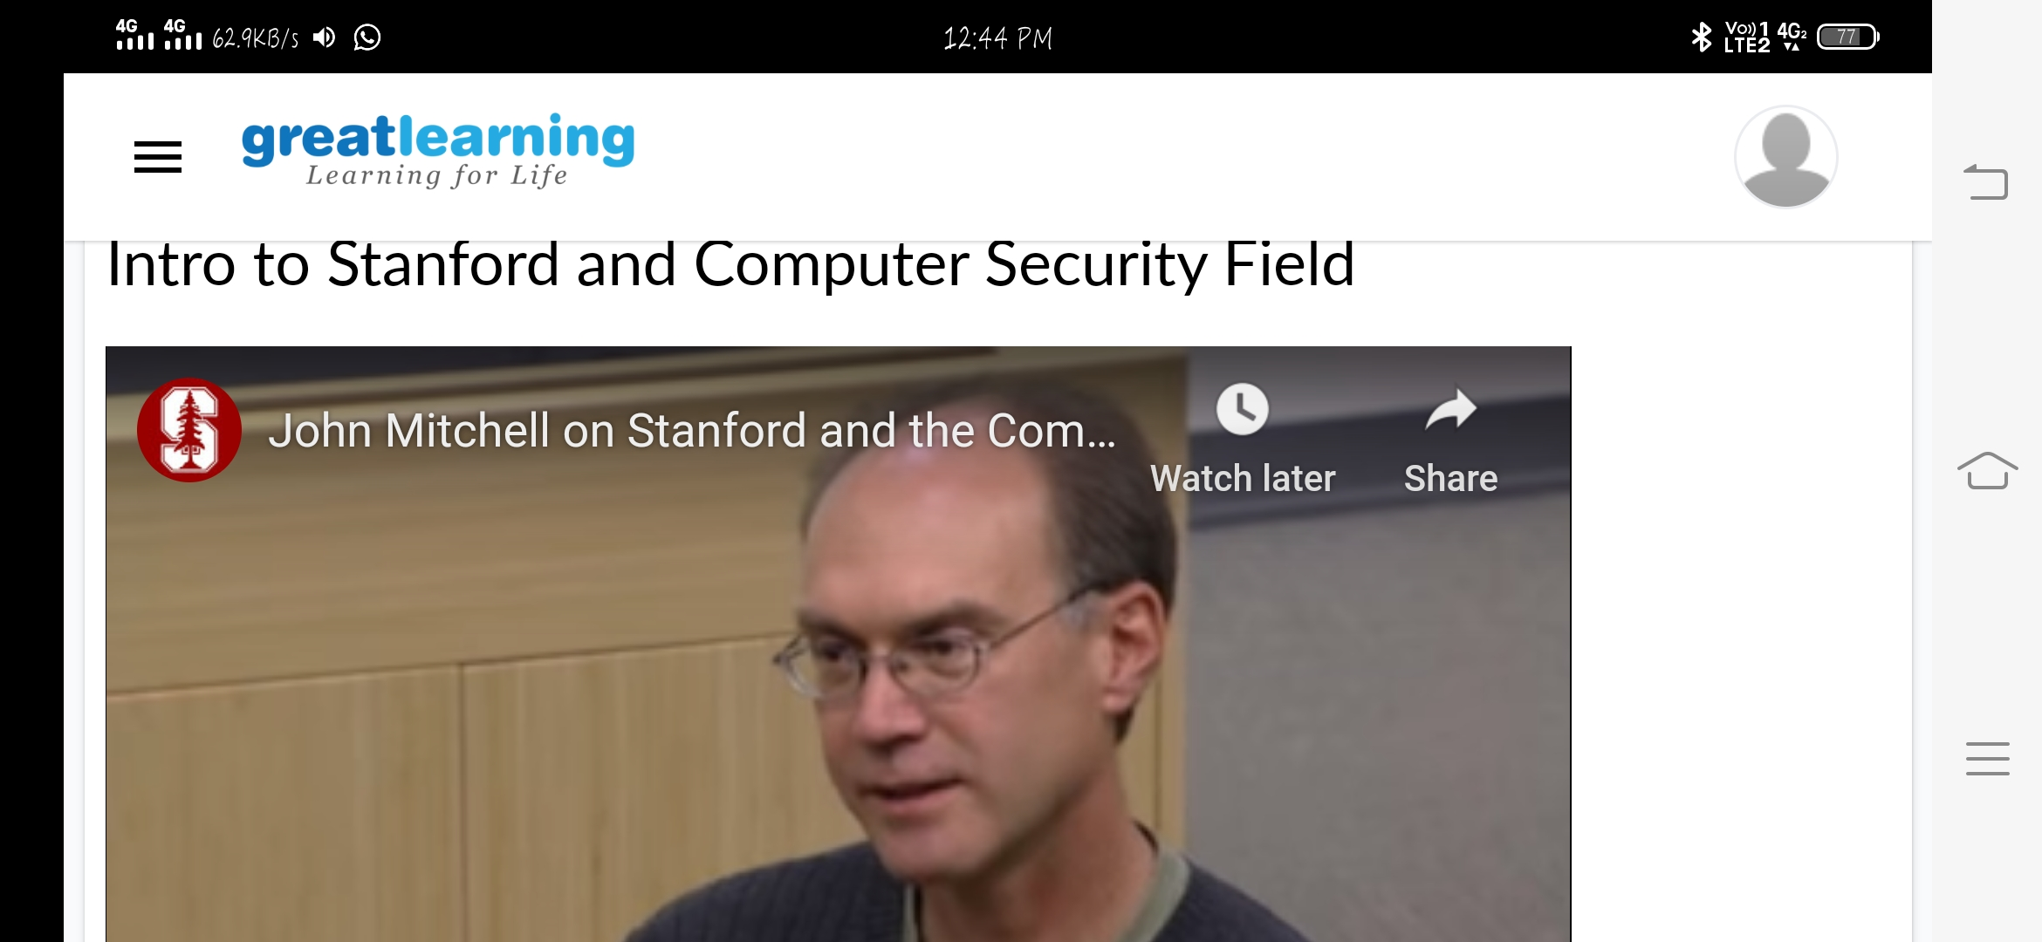

**CODING CHALLENGES DETAILS**: Every day we are given with new question of coding related to the language of java and c.

**Problem statement 1:**Write a Java program to count number of bits to be flipped to convert A to B.

**Solution is uploaded in Github**

**Snapshot:**

